Robotic Coverslipper

USER

MANUAL

Released on Sept.10th,2015 Implemented on Sept.10th,2015
Shandong Chiwell Biotechnology Co., Ltd.

Manufacturer：Shandong Chiwell Biotechnology Co., Ltd.

Register Address: Room 507,tower B ,1#Building
, Overseas Students Pioneer Park，No.69 Huayang road,Lixia district,Jinan city,Shandong province
Tel：86-531-82373282
Fax：86-531-82373282
After-sales service provider：Shandong Chiwell Biotechnology Co., Ltd.
After-sales service provider address：Room 507,tower B ,1#Building, Overseas Students Pioneer Park,No.69 Huayang road,Lixia district,Jinan city,Shandong province
After-sales service provider tel：86-531-82373282
Contents
1. General discription 3
1.1 Robotic Coverslipper’s breif introduction 3
1.2 Robotic Coverslipper’s operation principle 3
1.3 Indications： 3
1.4 contraindications： 3
None。 3
1.5 type and specifications 3
1.6 Operate and envrionmental conditions 4
2. Main structures 4
2.1 instrument structures introduction 4
3. Technical data 6
4. Instrument operation 6
4.1instrument main interface 6
Fig. 4 6
4.2 operate interface 7
4.2 coverslipping 10
5. instrument installation and debug test 10
5.1 install conditions 10
5.2 instrument debug test 11
6. notice 11
7.1 conditions of transport and storage 11
7.2 cleaning and maintenance 11
7.3 Approch of fuse replacement 12
7. SYMBOLS AND THEIR MEANINGS 12
8. standard accessorise 13
9. warranty and service 13
9.1warranty： 13
9.2technical service imformations ： 13
10. scrap process 14
11 notice 14
12instrument label 14

General discription

1.1 Robotic Coverslipper’s breif introduction
Robotic Coverslipper is used for slides with cells, blood and body fluid specimens automatic coverslipping instrument,developed and produced by Shandong Chiwell Biotechnology Co., Ltd.
Robotic Coverslipper is widely used in coverslipping process due to its high efficiency and stable coverslipping results with easy opratation,and also adopted by Pathalogy Department of all the major hospitals to replace artificial coverslipping gradually. Robotic Coverslipper is a high-tech instrument ,its all procedures automatically by micro controller.As our human-computer interface is easy to operate,our Robotic Coverslipper is very popular in wide range medical staffs by its outstanding performance.

1.2 Robotic Coverslipper’s Operation Principle
At the beginning users should put finished specimen slide into loading bath then click start to execute coverslipping procedures.It will alarm when it finished, and showing words such as "CLICK TO TAKE OUT" or "REACH THE LIMIT OF RESERVOIR" etc. on the screen.Users should take out from output magazine according to the devices status and manage it basis on corresponding keys on the screen.

1.3 Indications
Robotic Coverslipper is used for coverslipping of specimen slides with cells, blood and body fluid.

1.4 Contraindications：

None

1.5 Type and Specifications
Product title：Robotic Coverslipper
Type and specifications：as blow

Type | CW-400
Voltage Rating | AC220V 50Hz
Capacity | ≤350VA
Volume | 600（length）X 550（width）X 650（height）mm³

1.6 Operate and Environmental Conditions
- Supply Voltage: AC220V/50Hz；
- Working Current: < 1.75A；
- Ambient Temperature：+15℃～+35℃；
- Relative Air Humidity：30%～75%
- Atmospheric pressure：70kPa～106kPa

Main structures

2.1 Instrument Structures Introduction
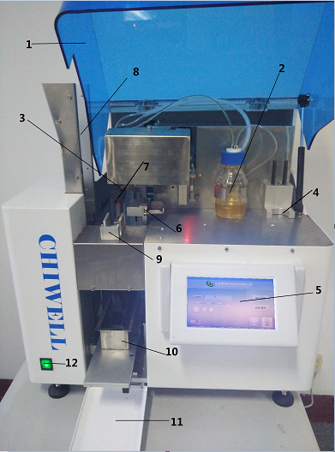

Fig. 1
Front View：
- Unit cover 7.Pick&Place module(coverslip mount)
- Bottle for coverslip mountant 8.Output magazine
- Dispenser group 9. Coverslip magazine
- Washer bottle position 10. Loading bath
- Control panel 11. Input door
- Specimen slides conveyor 12. Main switch
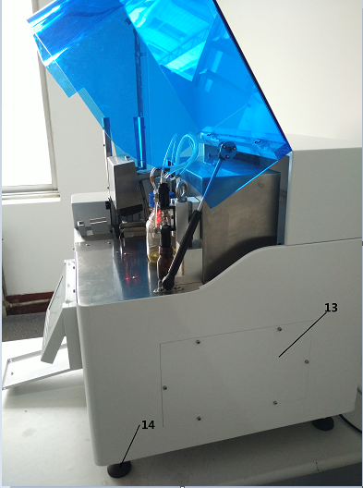

Fig. 2
Side View：
13.Access door 14.Height-adjustable instrument
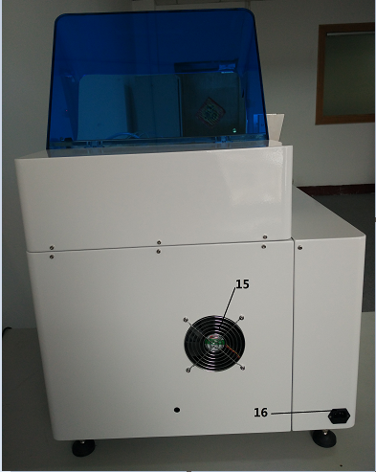

Fig. 3
Back View:
15：Ventilator fan 16：Power socket

Technical data
- Specimen slide throughput……………………………………200~400pieces/hour
- Specimen slide holders…………………………………………20~30pieces/holder
- Output magazines………………………………………………30piece/magazine
- Cover slip magazine capacity………………………… 120~160 pieces /magazine
- Specimen slide size…………………………………………………26*75mm
- Cover slip size………………………………………………………24*50mm
- Weight………………………………………………………………… 70kg

Instrument operation

4.1 Instrument Main Interface

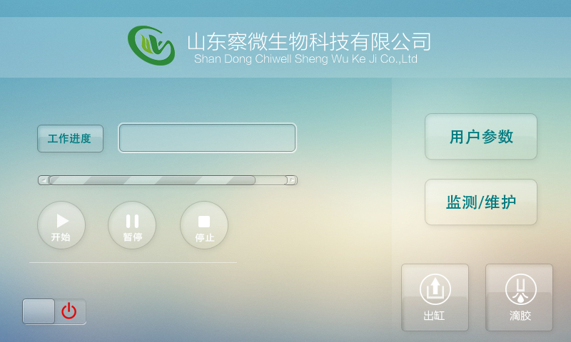

Fig. 4

Main Interface：
Start：The instrument is on standby state, initialization is completed, enter in the work interface
Dispensing：Adjust the dispensing volume and audio-visual state before it starts work
Operate Status：None
User Data：Failure
Test/Maintenance：Failure
Pause：Failure
Stop：Failure
Output：Failure

4.2 Operate Interface
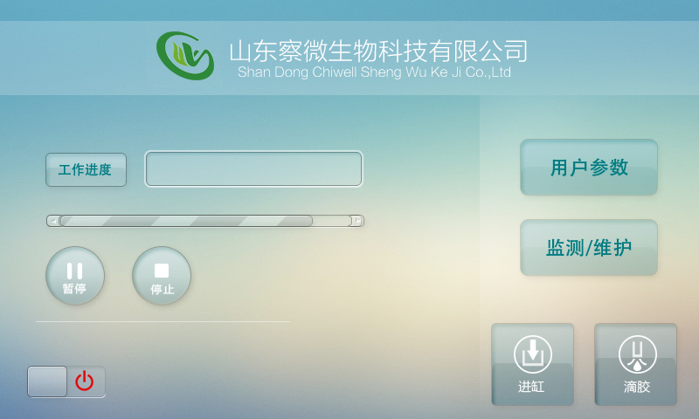
Fig. 5
Work progresses：It shows finished coverslipping quantity cumulatively.
User Data：Enter the user settings interface as shown in Fig. 6
Test/Maintenance：Enter the instrument debug test and repair interface as shown in Fig.8/9
Pause：The instrument enters a suspended state after the current process is executed, the machine stops working
Output：Only operate when the control panel prompts you to output,specimen slides loading bath running out of the it.
Input：Only operate when the control panel prompts you to input，specimen slides loading bath running into it.
Stop：The instrument resetting，restart and initialization.

4.3 User Data：
Click on ＂User Icon＂ to enter user settings interface. Input user data and parameter adjustment as below：
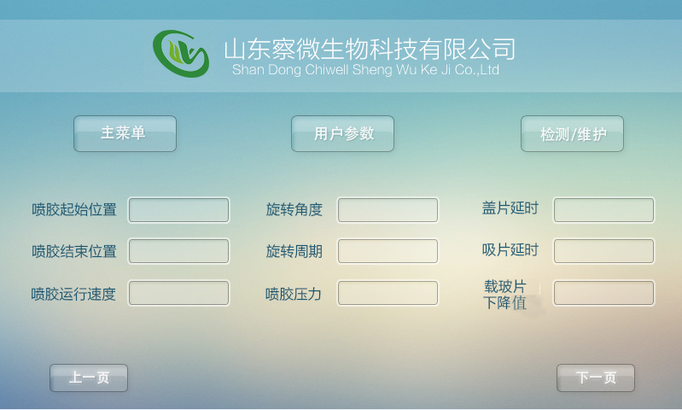
Fig. 6

1) Main Menu： Back to main interface.
2)User Data: Enter current interface.
3) Test/Maintenance： Enter test and maintenance interface.
4) Dispenser start position: Set dispensing start position on specimen slide.
5) Dispenser end position: Set dispensing end position on specimen slide.
6) Dispenser operation speed：Set dispensing process speed.
7) Rotational Angle：Set gripper rotational angle.
8) Rotational Period：Set gripper rotational speed.
9) Dispenser pressure value：Set pressure value of dispenser on the screen.
10)Coverslip latency： Setting cover glass at N ms，Coverslip unit rises.
11)Coverslip suction cup latency ：Setting coverslip act of suction is finished N ms，coverslip unit rises.
12)Specimen slides drop-out value：Adjust gripper position to catch the slide glass.

4.4 Test parameter：
Click on ＂Test/Maintenance＂ icon to enter setting＂Test/Maintenance＂interface，input ＂Test/Maintenance＂ and parameter adjustment as below：

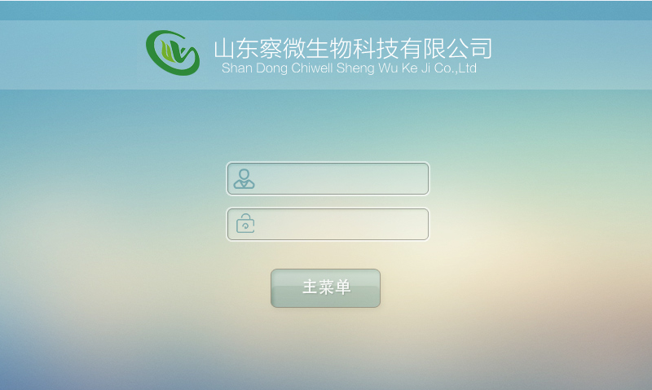
Fig. 7
Initial Password：
User：admin Password：123456

4.5 Test Parameter:
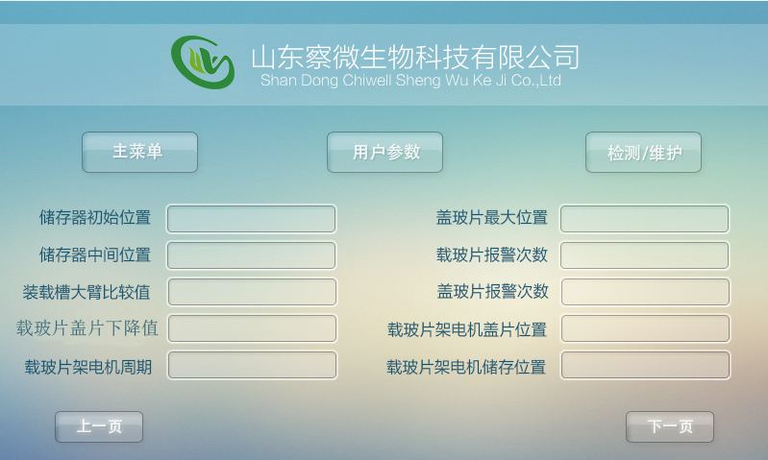
Fig. 8
1) Main Menu： Back to main interface.
2) User Data: Enter current interface.
3) Test/Maintenance： Enter test and maintenance interface.
4) Storage initial position： set initial position after the instrument reset.
5) Storage middle position： set space transition between two storage.
6)Loading bath upper arm fiducial data：set dividing data between slides holder and specimen slides，above this data is slides holder and under this data is specimen slides.
7) Specimen slides’ cover glass drop-out value：set specimen slides position for specimen slides motor to catch it.
8) Specimen slides holders motor period：set motor speed of specimen slides holder.
9) Cover slides utmost value：set forward working position of cover slide unit.
10)Specimen slides alarm times：set when gripper grab specimen slides failed for N times, sound the alarm.
11)Cover slides alarm times: set cover slides failed suction for N times, sound the alarm.
12)Cover slides of specimen slides holder position：set working position of specimen slides holders’ motor supporter.
13)Specimen slides holder storage position: set working position of covered specimen slides to its holder’s motor transfer to specimen slides collect magazine.
14)Next page：enter debug interface.

4.1.3Debug Interface：
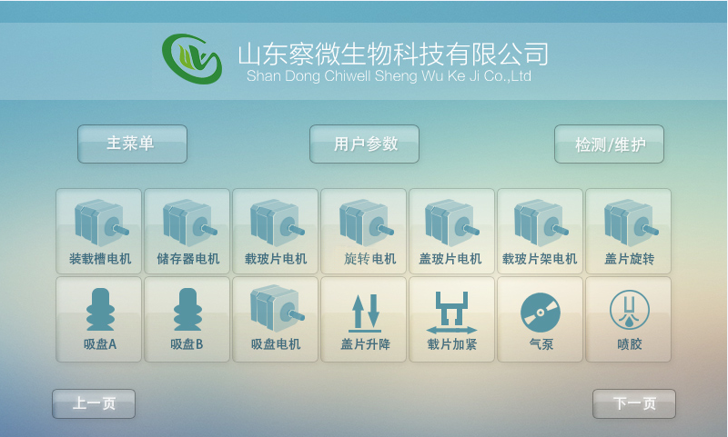
Fig. 9
1 Click on＂Loading bath motor＂＂storage motor＂＂specimen slides motor＂＂rotation motor＂＂cover slide motor＂＂specimen slides motor＂to debug corresponding motor.
2 Click on＂cover slide rotation＂＂suction cup A＂＂suction cup B＂＂suction cup motor＂＂coverslip lift＂＂specimen slides tighten＂＂pump＂＂Dispenser＂etc. to debug corresponding solenoid valve.

4.2 The coverslipping operation
You must be prepared as below before start coverslipping procedure.
- Open the unit cover，put dispenser needle to the specified position,make sure there is enough resin adhesive in bottle.
- Put the slides collect magazine on the specified position.
- Link power cord and to instrument and turn on the power switch,the instrument entered standby status.
- Click ＂Dispenser＂button on the screen to enter dispenser debug test.
- Put slides into loading bath,cover slides into cover slides storage.
- Start coverslipping.
- Waiting the machine to sound the alarm and make sure coverslipping finished.
- Take out slides holder and slides collect magazine.Put the spaying needle into the specified position to standby status/shutdown.
- Close the unit cover,turn off the instrument power switch.

Instrument Installation and Debug Test

5.1 Install Conditions
- Robotic Coverslipper requires fixed platform at length 1.5m and width 1m with good ventilate condition.
- Supply voltage is AC220V 50Hz，the instrument linked the part with PoE must be twice as much current.
- Fuse rated current is 2A.
- Detect instrument function when power on.
- Trained medical staffs to operate this instrument to avoid misoperation.
- Robotic Coverslipper should be setting in a room at least 20m²，electrical installation space is involved in grounding system and GFI system and so on.
- There should be enough space(almost 0.5m²) above lab worktable to open/close input door without obstacles.

5.2 Instrument Debug Test
- Put power cord insert standard three-wire type single phase socket.
- Observe and operate the function button on Control panel to check whether it’s working well.
- Test the dispensing function.
- Run coverslipping procedure.
- Turn off power and end test.

Notice
- Pull the power plug before you replacement fuse,and use the exact same type fuse.
- This instrument must operate by trained professional doctors with regular procedure.
- Please read this instruction carefully before use it.If you didn't according to instruction to operate and occurs undesirable consequences such as instrument damage or any other results, you should take responsibility by yourself,we won't undertake any.
- The instruments well grounding guaranteed it's safe for use.It must be grounding(single-phase 3-pole socket with well protective grounding is available)to avoid accident.
- It's not allowed to open the instrument case to avoid any fluid inflow it to occurs accident.
- Pull the power cord plug before you open the case with tools.
- Cut off power immediately when failures occurs in using it.
- Once this instruction is missing,please book one more from us.
- Product's care and maintenance.

7.1 Conditions of Transport and Storage
- Well packaged Robotic Coverslipper could be use normal means of transport,and should prevent sharp movements,crush and splash of rain or snow.
- Robotic Coverslipper's storage surroundings temperature is from 0℃ to 40℃，relative humidity should below 80%,no-corrosive gases with well ventilated room.

7.2 Cleaning and Maintenance
- Internal Take out reagent tank and rinse container,clean stainless steel inwall with mild detergent,then washing it.
- Coverslipping arm Coverslipping arm's internal includes wiring group so we can't use corrosive liquid to wash it. Only moist rags to wipe it lightly.
- External surface Clean it with mild detergent and then wipe it with moist rags.
- Touch screen Use screen cleaner to clean it.
- Loading bath Use standard lab dishwasher detergents to clean it.
- Dispenser needles Avoid accumulate dirt to breed bacteria especially algae,it must washing by dimethylbenzene regularly.
- Storage holder Use household or lab use detergent to wash it on demanded.

7.3 Approach of Fuse Replacement
Pull power plug,take off fuse cover by straight screwdriver from power plug and take out broken fuse and replace the same type fuse,then put on the power cover.
- Fuse type：F2L250V。

Symbols and their meanings
1 |  | B type instrument
2 |  | Protective Grounding
3 |  | Grounding
4 |  | Check out papers along with machine
5 |  | Fragile
6 |  | Keep dry
7 |  | This way upright
8 | 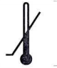 | Minimum temperature limited
9 | 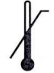 | Maximum temperature limited
10 |  | Fuse protector
11 | 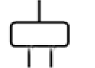 | Power plug
12 |  | AC/DC
13 |  | AC

Standard Accessorise
- User manual
- Power cables
- Specimen slides loading bath
- Product certificate
- Fuse F2L250V
- Specimen slides magazine
- Coverslips magazine
- Dispensing bottle
- Hairbrush
- Specimen slides tray
- Washer bottle

Warranty and Service

9.1 Warranty：
We promised that our products under contract adopted overall quality control procedures which is based on our internal test standard,all in good condition and meet all technical standards and stipulations.
Warranty limitation is based on our reached agreements, one year free guarantee from the day you bought(artificial damage is not include),lifetime maintenance.

9.2 Technical Service Informations:
If you need technical service or replace the parts,please contact us and offer these imformation as below:
- The instrument's type and title.
- The address of instrument and contact person.
- Reason for service call.
- Delivery date.

Disposal of the instrument:
The instrument or parts of the instrument must be disposed of according to existing applicable local regulations.

11 Notice
- It needs you to pour the used specimen slides into medical waste magazine.
- This instrument can't be used with electrosurgical generator at the same time.It maybe occurs failures when approach short-wave or microwave.

12 Instrument Label

Product Titile: Robotic Coverslipper
Product Tpe:CW-400
Product Code: Product Date: Month Date， Year
Input power:350VA
Production Manufacturer:
Shandong Chiwell Biotechnology Co., Ltd.
Manufacturer Address:
Room 507,tower B ,1#Building, Overseas Students Pioneer Park,No.69 Huayang road,Lixia district,Jinan city,Shandong province

